PROJECT REPORT
College Canteen Ordering System
Course: Database Management System (DBMS) Project
Submitted by
Name | Enrollment No.
Jenshi Patel | 12502080601047
Dharti Patel | 12502080601022

Submitted to: Yamini Dubey
B.Tech Information Technology, 2nd Year | Academic Year 2026–27
Date: October 2026

CERTIFICATE
This is to certify that the project report entitled “College Canteen Ordering System”, submitted in the subject of Database Management System (DBMS), is a bonafide work carried out by Jenshi Patel (12502080601047) and Dharti Patel (12502080601022), students of the Department of Information Technology, A.D. Patel Institute of Technology, during the academic year 2026–27.
The work embodied in this report has been carried out under the guidance of the faculty mentor and, to the best of our knowledge, is original and has not been submitted elsewhere for any other course or degree.
______________________  Faculty Mentor / Internal Examiner  Date: ______________ | ______________________  Head of Department  Date: ______________

ACKNOWLEDGEMENT
We would like to express our sincere gratitude to our faculty mentor, Yamini Dubey, for her valuable guidance, constant encouragement and constructive feedback throughout the development of this project. Her support helped us understand the practical side of database design and implementation.
We are also thankful to the Head of the Department of Information Technology and to the management of A.D. Patel Institute of Technology for providing the laboratory facilities and resources needed to complete this work. Finally, we thank our friends and families for their support and motivation.
— Jenshi Patel, Dharti Patel

ABSTRACT
The “College Canteen Ordering System” is a database-driven web application that replaces paper slips and manual cash handling in a college canteen. A student places an order for one or more food items through a browser form, the system calculates the bill, issues a token number that restarts every day, and tracks the order from Pending to Collected. Stock is reduced automatically when an order is placed, and items that are running low are flagged for the canteen staff. At the end of the day a stored procedure summarises the total orders and revenue.
The database has five tables – Students, Food_Items, Orders, Order_Items and Daily_Sales – normalised to Third Normal Form and implemented in MySQL with primary keys, foreign keys, CHECK and UNIQUE constraints. A trigger, a view, a stored function and a stored procedure enforce business rules inside the database. The front end uses HTML and CSS pages written in PHP, which run on Apache through XAMPP and talk to MySQL with prepared statements and transactions. The project covers ER modelling, normalisation, JOIN and GROUP BY queries, and transaction-safe order processing.
Keywords: DBMS, MySQL, PHP, Canteen Ordering, ER Diagram, Normalisation, Trigger, Stored Procedure, Transactions.
CONTENTS
1. Introduction & System Requirements 4
1.1 Background 4
1.2 Scope of the Project 4
1.3 Objectives 4
1.4 Hardware & Software Specifications 4
2. Database Design 5
2.1 Requirement Analysis & Business Rules 5
2.2 Entity-Relationship (ER) Diagram 6
2.3 Relational Schema & Data Dictionary 7
2.4 Normalisation Analysis 8
3. Implementation 10
3.1 Table Creation (DDL) 10
3.2 Trigger, Function, Procedure and Views 11
3.3 Data Insertion (DML) and Analytical Queries 12
3.4 Application Layer (HTML, CSS and PHP) 12
4. Sample Output Reports / Query Results 14
4.1 Interface / Form Screenshots 14
4.2 Stored Data and Database Objects 16
4.3 Query Results 17
4.4 Test Summary 18
5. Conclusion & References 19
5.1 Summary 19
5.2 Limitations & Future Improvements 19
5.3 References / Sources 19

1. INTRODUCTION & SYSTEM REQUIREMENTS

1.1 Background
A college canteen serves hundreds of students in short breaks between lectures. Many canteens still take orders on paper slips and collect cash at the counter. This causes long queues, mixed-up orders, wasted food and no reliable record of what was sold. The owner cannot easily tell which items sell best, when stock will run out, or how much was earned on a given day.
A database system solves these problems by storing every order in a structured form. Each order receives a token number, its items and prices are recorded, and the stock is updated at the same moment. Reports that took an hour of manual totalling can then be produced with a single query.

1.2 Scope of the Project
The system covers the following activities:
- Displaying the menu with price and live stock for every food item.
- Placing an order with several items, with automatic bill calculation and a daily token number.
- Updating an order through the states Pending, Preparing, Ready, Collected and Cancelled.
- Listing today’s orders and low-stock items.
- Generating an end-of-day sales report with total orders, revenue and best-selling items.
Online payment, user login and multi-canteen support are outside the scope of this project and are listed under future improvements.

1.3 Objectives
- To design a normalised relational schema (up to 3NF) for a college canteen ordering environment.
- To enforce data integrity using primary keys, foreign keys, UNIQUE, NOT NULL and CHECK constraints.
- To keep stock and totals correct with a trigger, issue a daily token with a stored function, and produce the end-of-day summary with a stored procedure.
- To build a PHP front end that places orders inside a database transaction so that a failed order saves nothing.

1.4 Hardware & Software Specifications
Component | Specification
Hardware | Intel Core i3 or equivalent, or higher; 4 GB RAM minimum; 500 MB free disk space
Operating system | Windows 10 or 11
Web server | Apache and PHP, installed with XAMPP
Database | MySQL (CHECK constraints need 8.0.16 or later) or the MariaDB bundled with XAMPP, managed through phpMyAdmin
Front end | HTML and CSS pages generated by PHP; a modern browser such as Chrome
Design tools | draw.io or similar for the ER diagram

2. DATABASE DESIGN

2.1 Requirement Analysis & Business Rules
The requirements were gathered from how a typical canteen works. They were converted into the following business rules, which the database enforces wherever possible.
- BR1. Every student is identified by a unique enrollment number.
- BR2. A student can place many orders, but each order belongs to exactly one student.
- BR3. An order contains one or more items, and the same item can appear in many orders.
- BR4. Price and quantity must be greater than zero, and stock can never be negative.
- BR5. Each order gets a token number that is unique within its date and restarts at 1 every day.
- BR6. The price of an item is copied into the order line, so a later price change does not alter old bills.
- BR7. Placing an order reduces stock; cancelling an order returns the stock.
- BR8. Cancelled orders are excluded from daily sales.

Functional Requirements
Module | Requirement
Menu management | Display food items grouped by category with price and live stock, and flag items with low stock.
Order placement | Accept an order of several items for a student, calculate the bill and issue a daily token number.
Order tracking | Move an order through Pending, Preparing, Ready and Collected, or cancel it.
Stock control | Reduce stock when an order is placed, return it on cancellation and list low-stock items.
Reporting | Produce an end-of-day report of orders and revenue, with the best-selling items.

2.2 ENTITY-RELATIONSHIP (ER) DIAGRAM
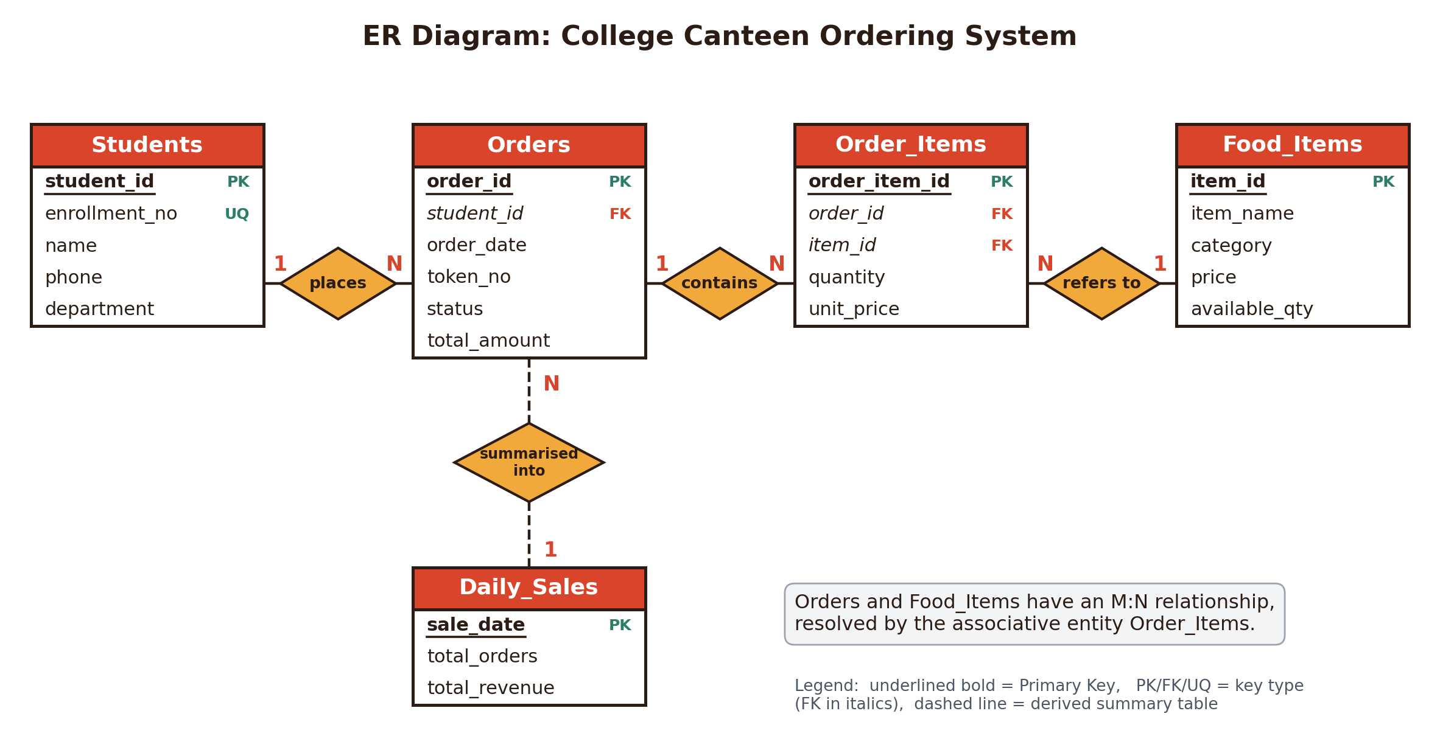
Figure 1: ER diagram of the College Canteen Ordering System (primary keys underlined)
The system has five entities. Students places Orders (1:N). Orders contains Order_Items (1:N) and Food_Items is referred to by Order_Items (1:N). Therefore Orders and Food_Items have a many-to-many relationship, which is resolved by the associative entity Order_Items. Daily_Sales is a derived summary table filled from Orders by a stored procedure.
Relationship | Entities | Cardinality | Meaning
places | Students - Orders | 1 : N | One student places many orders
contains | Orders - Order_Items | 1 : N | One order has many item lines
refers to | Food_Items - Order_Items | 1 : N | One food item appears on many lines
(resolved) | Orders - Food_Items | M : N | Through Order_Items
summarised into | Orders - Daily_Sales | N : 1 | Many orders roll up into one day

2.3 RELATIONAL SCHEMA & DATA DICTIONARY
Each entity is mapped to one table. The foreign keys come from the 1:N relationships, and the M:N relationship is stored in Order_Items, whose two foreign keys point to Orders and Food_Items. The relational schema implemented in MySQL is given below (PK = primary key, FK = foreign key), and Figure 2 shows the tables as created in phpMyAdmin.
- Students(student_id [PK], enrollment_no [Unique], name, phone, department)
- Food_Items(item_id [PK], item_name [Unique], category, price, available_qty)
- Orders(order_id [PK], student_id [FK], order_date, token_no, status, total_amount)
- Order_Items(order_item_id [PK], order_id [FK], item_id [FK], quantity, unit_price)
- Daily_Sales(sale_date [PK], total_orders, total_revenue)
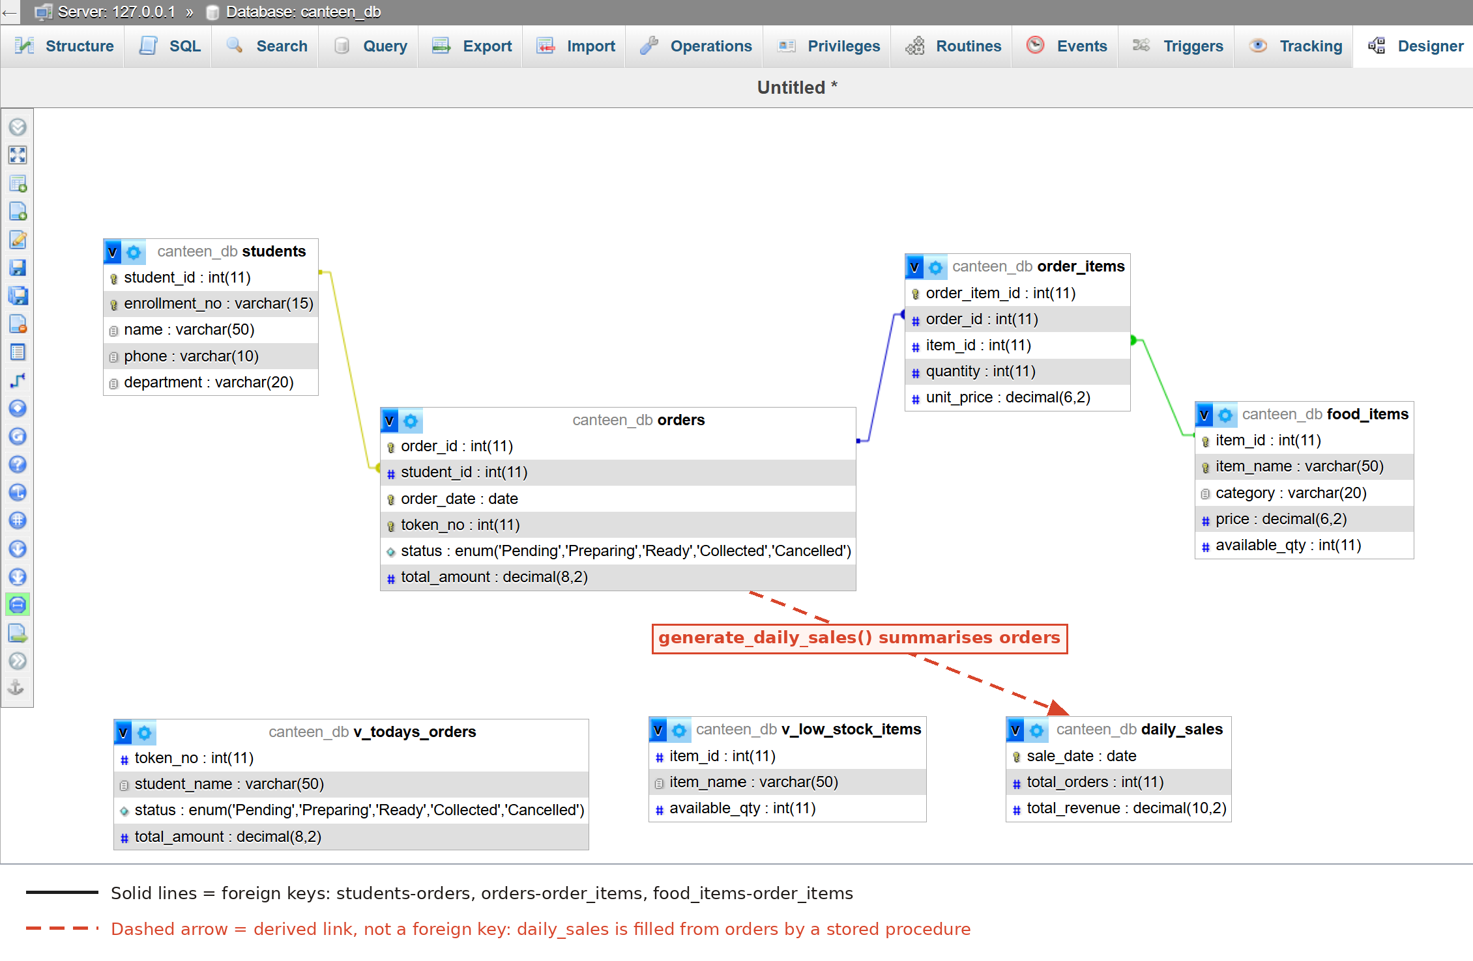
Figure 2: Table relationships in phpMyAdmin Designer. The dashed arrow marks the derived link from Orders to Daily_Sales, which is not a foreign key

Data Dictionary
Table | Column | Data Type | Constraints
Students | student_id | INT | PRIMARY KEY, AUTO_INCREMENT
 | enrollment_no | VARCHAR(15) | UNIQUE, NOT NULL
 | name | VARCHAR(50) | NOT NULL
 | phone | VARCHAR(10) | Nullable
 | department | VARCHAR(20) | Nullable
Food_Items | item_id | INT | PRIMARY KEY, AUTO_INCREMENT
 | item_name | VARCHAR(50) | UNIQUE, NOT NULL
 | category | VARCHAR(20) | NOT NULL
 | price | DECIMAL(6,2) | NOT NULL, CHECK (price > 0)
 | available_qty | INT | NOT NULL, DEFAULT 0, CHECK (>= 0)
Orders | order_id | INT | PRIMARY KEY, AUTO_INCREMENT
 | student_id | INT | NOT NULL, FOREIGN KEY → Students
 | order_date | DATE | NOT NULL
 | token_no | INT | NOT NULL, UNIQUE with order_date
 | status | ENUM(5 values) | NOT NULL, DEFAULT 'Pending'
 | total_amount | DECIMAL(8,2) | NOT NULL, DEFAULT 0
Order_Items | order_item_id | INT | PRIMARY KEY, AUTO_INCREMENT
 | order_id | INT | NOT NULL, FOREIGN KEY → Orders (ON DELETE CASCADE)
 | item_id | INT | NOT NULL, FOREIGN KEY → Food_Items
 | quantity | INT | NOT NULL, CHECK (quantity > 0)
 | unit_price | DECIMAL(6,2) | NOT NULL, CHECK (unit_price > 0)
Daily_Sales | sale_date | DATE | PRIMARY KEY
 | total_orders | INT | NOT NULL, DEFAULT 0
 | total_revenue | DECIMAL(10,2) | NOT NULL, DEFAULT 0

2.4 NORMALISATION ANALYSIS
Unnormalised form. A single sheet ORDER(order_id, order_date, token_no, enrollment_no, student_name, phone, {item_name, category, price, quantity}) repeats the item group inside every order and repeats student details in every order.
- 1NF (First Normal Form): Every column holds one atomic value. The repeating group {item_name, category, price, quantity} is moved into its own table, so each order line is one row in Order_Items. No column stores a list.
- 2NF (Second Normal Form): There is no partial dependency on part of a composite key. In the 1NF order line with key (order_id, item_name), the columns category and price depend only on item_name, so they are moved to Food_Items, whose key is the single column item_id. All tables use a single-column primary key, so partial dependency cannot occur.
- 3NF (Third Normal Form): No non-key column depends on another non-key column. Student name, phone and department depend on the student, not on the order, so they sit in Students and Orders keeps only student_id. In every table the functional dependencies are of the form key → attributes:
- Students: student_id → enrollment_no, name, phone, department
- Food_Items: item_id → item_name, category, price, available_qty
- Orders: order_id → student_id, order_date, token_no, status, total_amount
- Order_Items: order_item_id → order_id, item_id, quantity, unit_price
- Daily_Sales: sale_date → total_orders, total_revenue
Conclusion: The College Canteen Ordering System follows 3NF, reducing data redundancy and improving data consistency.

Design Notes
Two columns are stored on purpose. unit_price in Order_Items freezes the price at the time of sale (BR6). total_amount in Orders and the Daily_Sales table are derived values kept correct by a trigger and a stored procedure, which makes billing and reporting fast. These are controlled design decisions, not normalisation errors.

Normal Form Summary
Table | 1NF | 2NF | 3NF
Students | Satisfied | Satisfied | Satisfied
Food_Items | Satisfied | Satisfied | Satisfied
Orders | Satisfied | Satisfied | Satisfied
Order_Items | Satisfied | Satisfied | Satisfied
Daily_Sales | Satisfied | Satisfied | Satisfied

Integrity Constraints Used
- PRIMARY KEY with AUTO_INCREMENT on every table except Daily_Sales (keyed by sale_date) for unique identification.
- UNIQUE on enrollment_no, item_name and (order_date, token_no) to prevent duplicates, including a repeated token on the same day.
- FOREIGN KEY constraints to keep orders, students, order lines and food items consistent; ON DELETE CASCADE removes the lines of a deleted order.
- CHECK constraints on price, available_qty, quantity and unit_price to block invalid data and negative stock.
- ENUM on status to limit an order to Pending, Preparing, Ready, Collected or Cancelled.

3. IMPLEMENTATION

3.1 Table Creation (DDL)
The database is created in MySQL 8.0 in dependency order: Students and Food_Items first, then Orders, which references Students, then Order_Items, which references Orders and Food_Items, and finally Daily_Sales. The complete script, including sample data, is supplied in the file canteen_db.sql.
CREATE DATABASE canteen_db; USE canteen_db;

CREATE TABLE Students (
student_id INT AUTO_INCREMENT PRIMARY KEY,
enrollment_no VARCHAR(15) NOT NULL UNIQUE,
name VARCHAR(50) NOT NULL,
phone VARCHAR(10),
department VARCHAR(20)
);
CREATE TABLE Food_Items (
item_id INT AUTO_INCREMENT PRIMARY KEY,
item_name VARCHAR(50) NOT NULL UNIQUE,
category VARCHAR(20) NOT NULL,
price DECIMAL(6,2) NOT NULL CHECK (price > 0),
available_qty INT NOT NULL DEFAULT 0 CHECK (available_qty >= 0)
);
CREATE TABLE Orders (
order_id INT AUTO_INCREMENT PRIMARY KEY,
student_id INT NOT NULL,
order_date DATE NOT NULL,
token_no INT NOT NULL,
status ENUM('Pending','Preparing','Ready','Collected','Cancelled')
NOT NULL DEFAULT 'Pending',
total_amount DECIMAL(8,2) NOT NULL DEFAULT 0,
CONSTRAINT fk_orders_student FOREIGN KEY (student_id)
REFERENCES Students(student_id),
CONSTRAINT uq_token_per_day UNIQUE (order_date, token_no)
);
CREATE TABLE Order_Items (
order_item_id INT AUTO_INCREMENT PRIMARY KEY,
order_id INT NOT NULL,
item_id INT NOT NULL,
quantity INT NOT NULL CHECK (quantity > 0),
unit_price DECIMAL(6,2) NOT NULL CHECK (unit_price > 0),
CONSTRAINT fk_oi_order FOREIGN KEY (order_id)
REFERENCES Orders(order_id) ON DELETE CASCADE,
CONSTRAINT fk_oi_item FOREIGN KEY (item_id)
REFERENCES Food_Items(item_id)
);
CREATE TABLE Daily_Sales (
sale_date DATE PRIMARY KEY,
total_orders INT NOT NULL DEFAULT 0,
total_revenue DECIMAL(10,2) NOT NULL DEFAULT 0
);

3.2 Trigger, Function, Procedure and Views
The trigger below keeps stock and order totals correct. If an order asks for more than the available stock, the CHECK constraint on available_qty fails, the INSERT is rejected with an error and the PHP code rolls back the whole order, so stock can never become negative. The function returns the next token for a date, the procedure builds the daily summary, and the views give quick lists for the canteen staff.
DELIMITER //
CREATE TRIGGER trg_after_order_item_insert
AFTER INSERT ON Order_Items FOR EACH ROW
BEGIN
UPDATE Food_Items SET available_qty = available_qty - NEW.quantity
WHERE item_id = NEW.item_id;
UPDATE Orders SET total_amount = total_amount + NEW.quantity * NEW.unit_price
WHERE order_id = NEW.order_id;
END//

CREATE FUNCTION get_next_token(p_date DATE) RETURNS INT
READS SQL DATA
BEGIN
DECLARE t INT;
SELECT COALESCE(MAX(token_no), 0) + 1 INTO t
FROM Orders WHERE order_date = p_date;
RETURN t;
END//

CREATE PROCEDURE generate_daily_sales(IN p_date DATE)
BEGIN
INSERT INTO Daily_Sales (sale_date, total_orders, total_revenue)
SELECT p_date, COUNT(*), COALESCE(SUM(total_amount), 0)
FROM Orders WHERE order_date = p_date AND status <> 'Cancelled'
ON DUPLICATE KEY UPDATE total_orders = VALUES(total_orders),
total_revenue = VALUES(total_revenue);
END//
DELIMITER ;

CREATE VIEW v_todays_orders AS
SELECT o.token_no, s.name AS student_name, o.status, o.total_amount
FROM Orders o JOIN Students s ON o.student_id = s.student_id
WHERE o.order_date = CURDATE();

CREATE VIEW v_low_stock_items AS
SELECT item_id, item_name, available_qty FROM Food_Items
WHERE available_qty < 10;

3.3 Data Insertion (DML) and Analytical Queries
Sample data was loaded with INSERT statements: 10 students, 15 food items and 15 orders spread over two days. Dates are written relative to CURDATE() so that the views always show data. The four analytical queries are given below, and their results appear in Chapter 4.
-- Q1: order details with student and item names (JOIN of four tables)
SELECT o.token_no, s.name AS student, f.item_name, oi.quantity,
oi.quantity * oi.unit_price AS subtotal
FROM Orders o
JOIN Students s ON o.student_id = s.student_id
JOIN Order_Items oi ON o.order_id = oi.order_id
JOIN Food_Items f ON oi.item_id = f.item_id
WHERE o.order_date = CURDATE() ORDER BY o.token_no LIMIT 8;

-- Q2: revenue per category (GROUP BY)
SELECT f.category, SUM(oi.quantity) AS units_sold,
SUM(oi.quantity * oi.unit_price) AS revenue
FROM Order_Items oi
JOIN Food_Items f ON oi.item_id = f.item_id
JOIN Orders o ON oi.order_id = o.order_id
WHERE o.status <> 'Cancelled'
GROUP BY f.category ORDER BY revenue DESC;

-- Q3: best-selling items today
SELECT f.item_name, SUM(oi.quantity) AS total_sold
FROM Order_Items oi
JOIN Food_Items f ON oi.item_id = f.item_id
JOIN Orders o ON oi.order_id = o.order_id
WHERE o.order_date = CURDATE() AND o.status <> 'Cancelled'
GROUP BY f.item_name ORDER BY total_sold DESC LIMIT 5;

-- Q4: students who spent more than 100 (GROUP BY with HAVING)
SELECT s.name, COUNT(o.order_id) AS orders_placed,
SUM(o.total_amount) AS total_spent
FROM Students s JOIN Orders o ON s.student_id = o.student_id
WHERE o.status <> 'Cancelled'
GROUP BY s.student_id, s.name
HAVING SUM(o.total_amount) > 100 ORDER BY total_spent DESC;

3.4 Application Layer (HTML, CSS and PHP)
The front end is a set of PHP pages in the folder htdocs/canteen. A shared header.php and footer.php give every page the same top bar, and style.css holds the styling. db.php opens one mysqli connection that every page includes.
File | Purpose | Database objects used
index.php | Home page with item count, today’s orders and revenue | Food_Items, Orders
menu.php | Menu grouped by category with stock and Low label | Food_Items
order.php | Order form, bill total, order placement | get_next_token(), trigger, Orders, Order_Items
orders.php | Today’s orders, next-status and cancel buttons | Orders, Order_Items, Food_Items
report.php | Sales report for a chosen date, low stock, history | generate_daily_sales(), Daily_Sales, v_low_stock_items

Placing an order runs as one transaction. The page reads the price of every item from the database, never from the form, so a price cannot be changed in the browser. If any step fails, for example because stock is insufficient, the transaction is rolled back and nothing is saved.
$conn->begin_transaction();
$token = (int)$conn->query("SELECT get_next_token(CURDATE()) AS t")
->fetch_assoc()['t'];
$stmt = $conn->prepare("INSERT INTO Orders (student_id, order_date, token_no)
VALUES (?, CURDATE(), ?)");
$stmt->bind_param("ii", $student_id, $token);
$stmt->execute();
$order_id = $conn->insert_id;
$insStmt = $conn->prepare("INSERT INTO Order_Items
(order_id, item_id, quantity, unit_price)
VALUES (?, ?, ?, ?)");
foreach ($cart as $item_id => $q) {
$price = $prices[$item_id]; // read earlier from Food_Items, not from the form
// the trigger then updates stock and the order total
$insStmt->bind_param("iiid", $order_id, $item_id, $q, $price);
$insStmt->execute();
}
$conn->commit(); // on any error: $conn->rollback();

The orders page locks the order row with SELECT ... FOR UPDATE before changing its status. Moving to the next status is allowed only in the order Pending, Preparing, Ready, Collected. Cancelling is allowed only for Pending or Preparing orders, and it returns the stock of every item in the order. The report page calls the stored procedure for the chosen date and then reads the summary row, the best sellers and the revenue per category.

4. SAMPLE OUTPUT REPORTS / QUERY RESULTS

4.1 Interface / Form Screenshots
The home page shows the number of menu items, the orders placed today and today’s revenue, with shortcuts to the main pages.
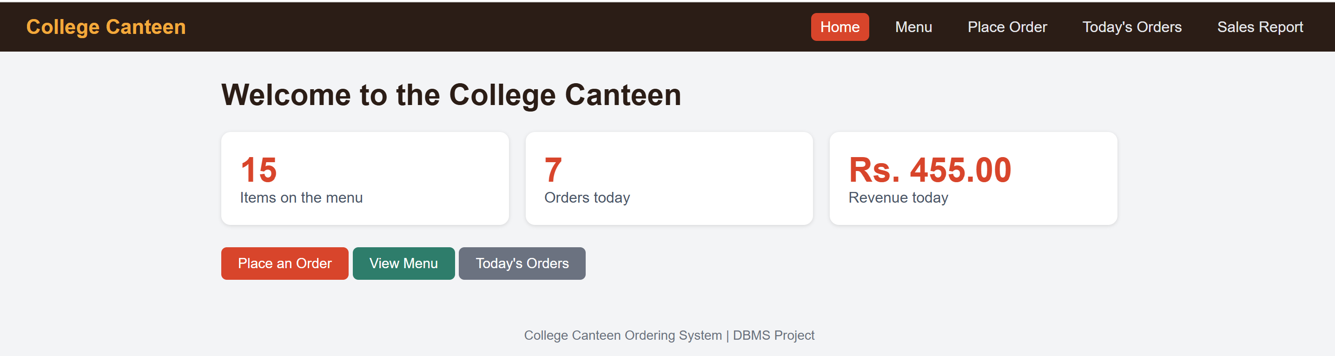
Figure 3: Home page
The menu page groups items by category. Items with fewer than 10 units left are marked Low, for example Ice Cream.
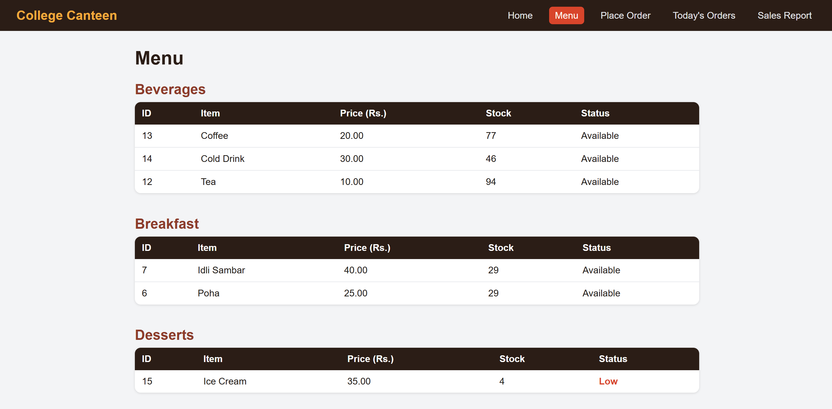
Figure 4: Menu with live stock
On the order form the student is chosen from a list and a quantity is entered for each item. The bill total updates as quantities change. The quantity box accepts only values up to the stock in hand, so a value above the stock is refused.
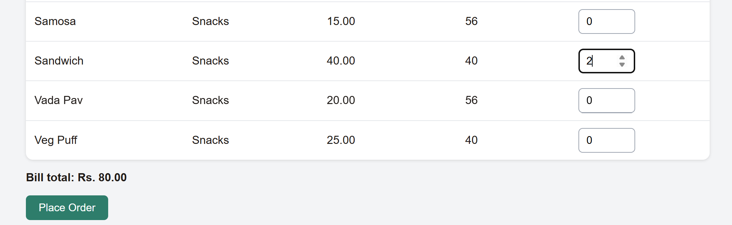
Figure 5: Order form with a live bill total
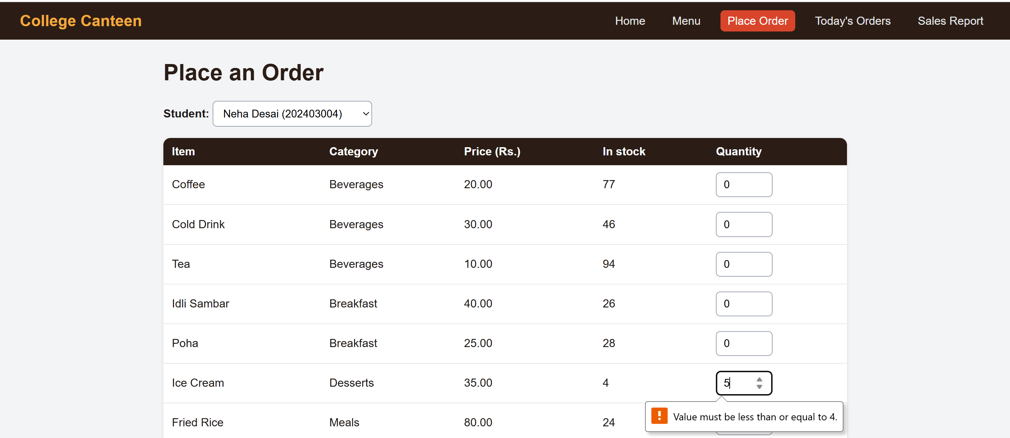
Figure 6: Quantity above stock is refused (Ice Cream has 4 in stock)
After the order is saved, the page shows the token number and the total calculated by the database.
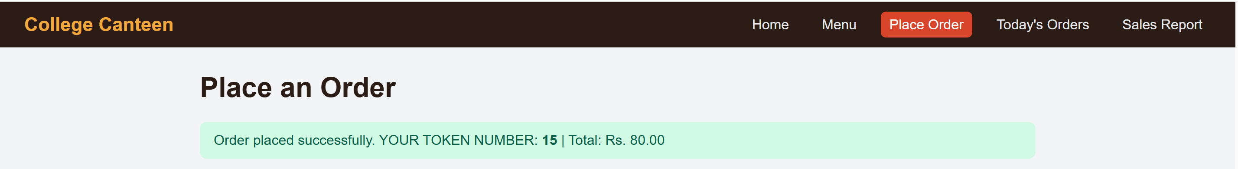
Figure 7: Order placed with token number 15 and total Rs. 80.00
The Today’s Orders page lists every order with its items, amount and status. The buttons move an order to its next status, and Cancel returns the stock.
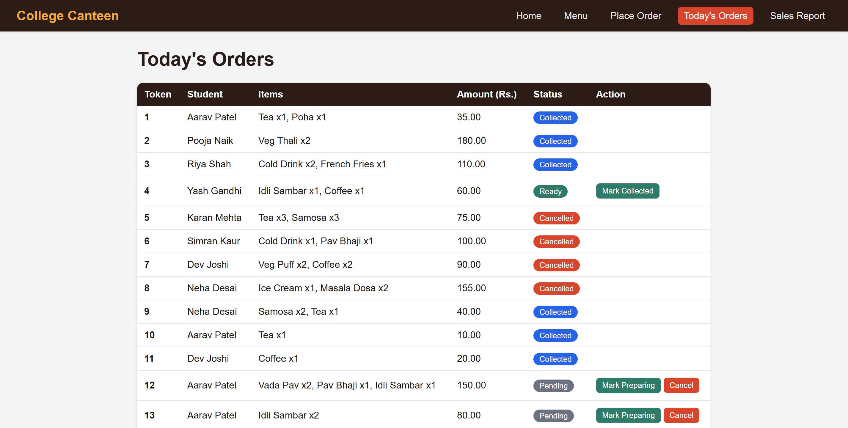
Figure 8: Today’s orders with status buttons
The sales report shows the number of orders and the revenue for the chosen date. Cancelled orders are not counted.
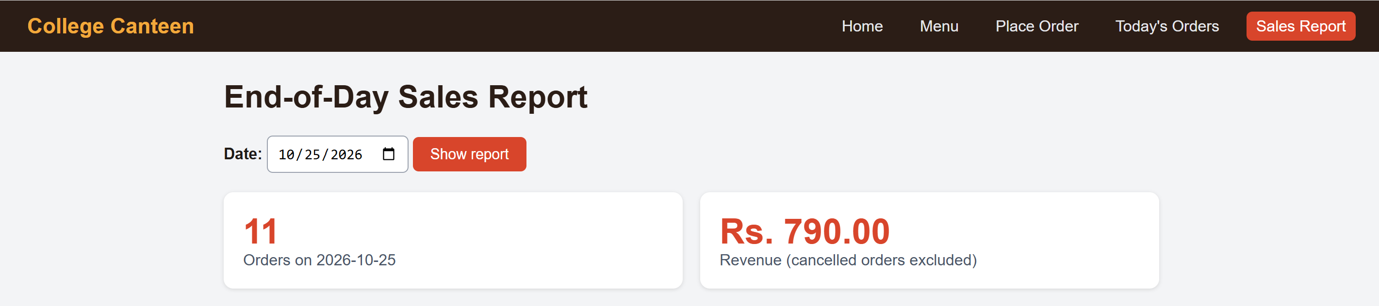
Figure 9: End-of-day sales report for 25 October 2026

4.2 Stored Data and Database Objects
The Orders table holds orders from two days with all five statuses. Token numbers restart at 1 on each date, and total_amount was filled in by the trigger.
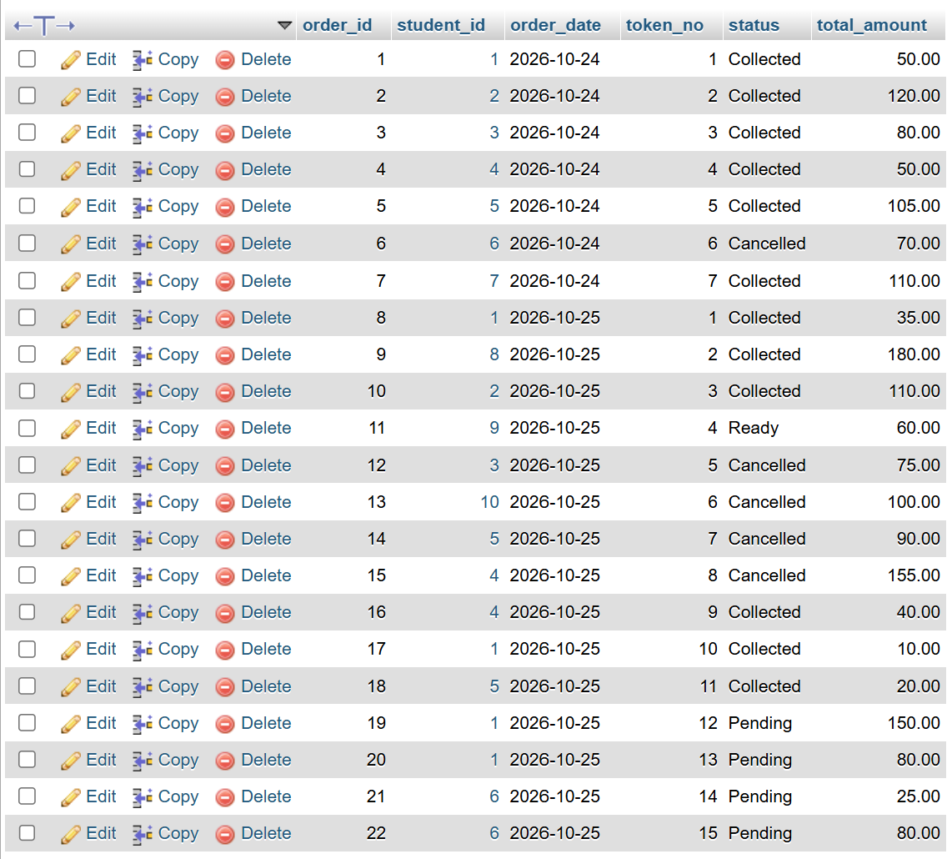
Figure 10: Orders table in phpMyAdmin
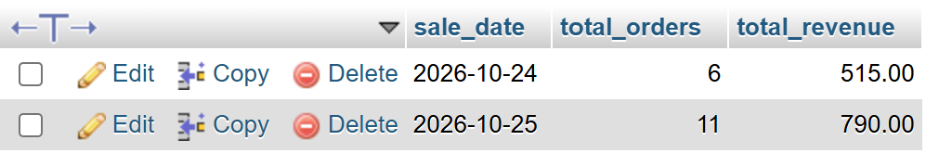
Figure 11: Daily_Sales table filled by generate_daily_sales()
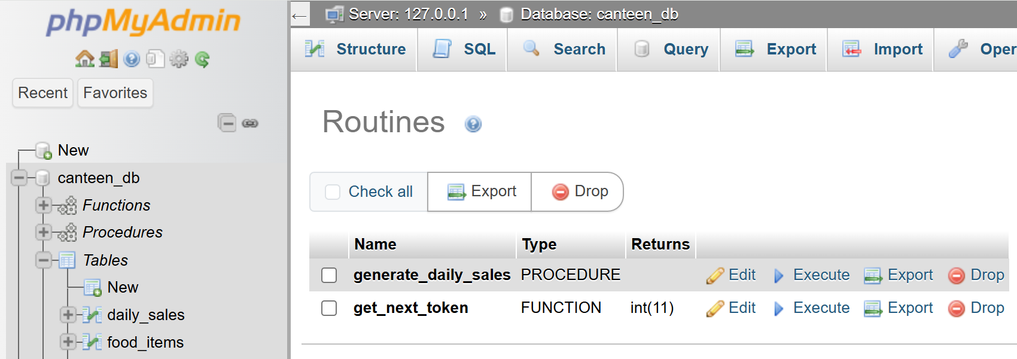
Figure 12: Stored procedure and function in the database
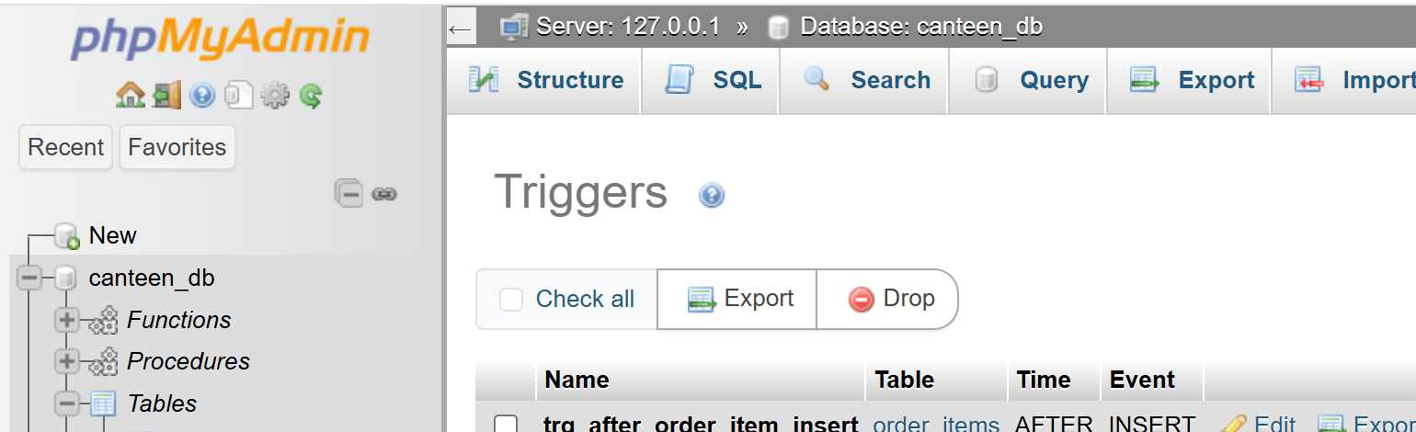
Figure 13: Trigger trg_after_order_item_insert on Order_Items

4.3 Query Results
Q1 joins four tables to show what each student ordered today.
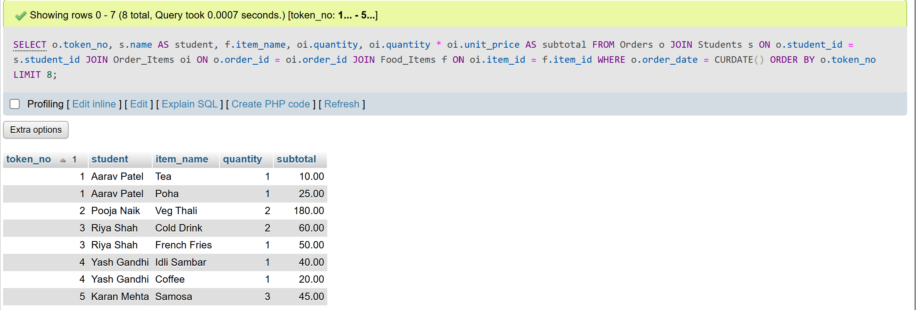
Figure 14: Output of Q1 (order details, first 8 rows)
Q2 shows that Meals bring the highest revenue. Q3 lists the best-selling items of the day.
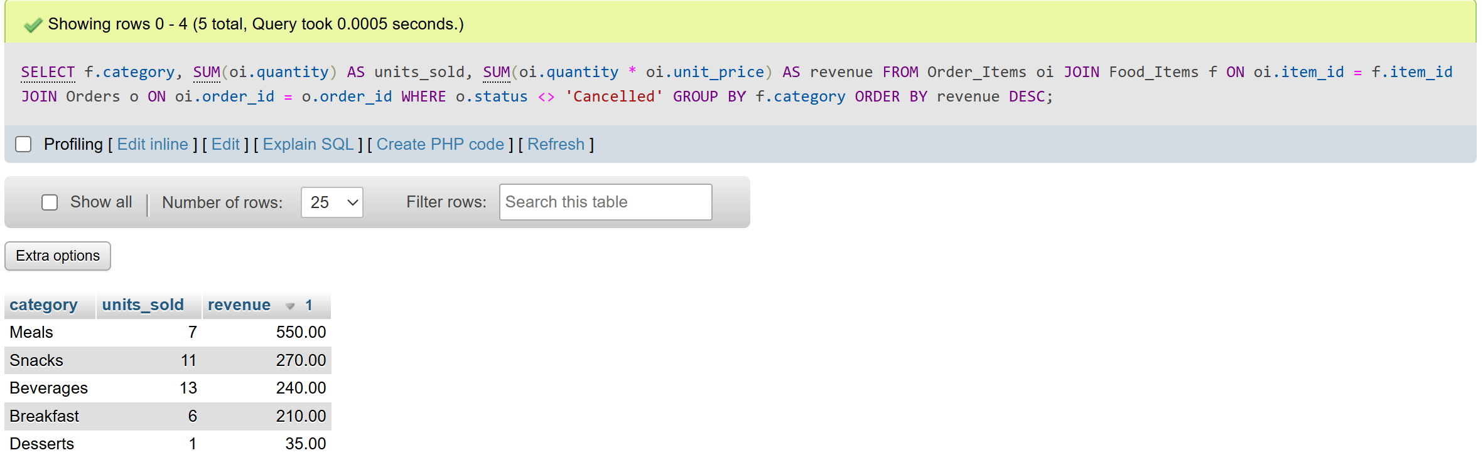
Figure 15: Output of Q2 (revenue per category)
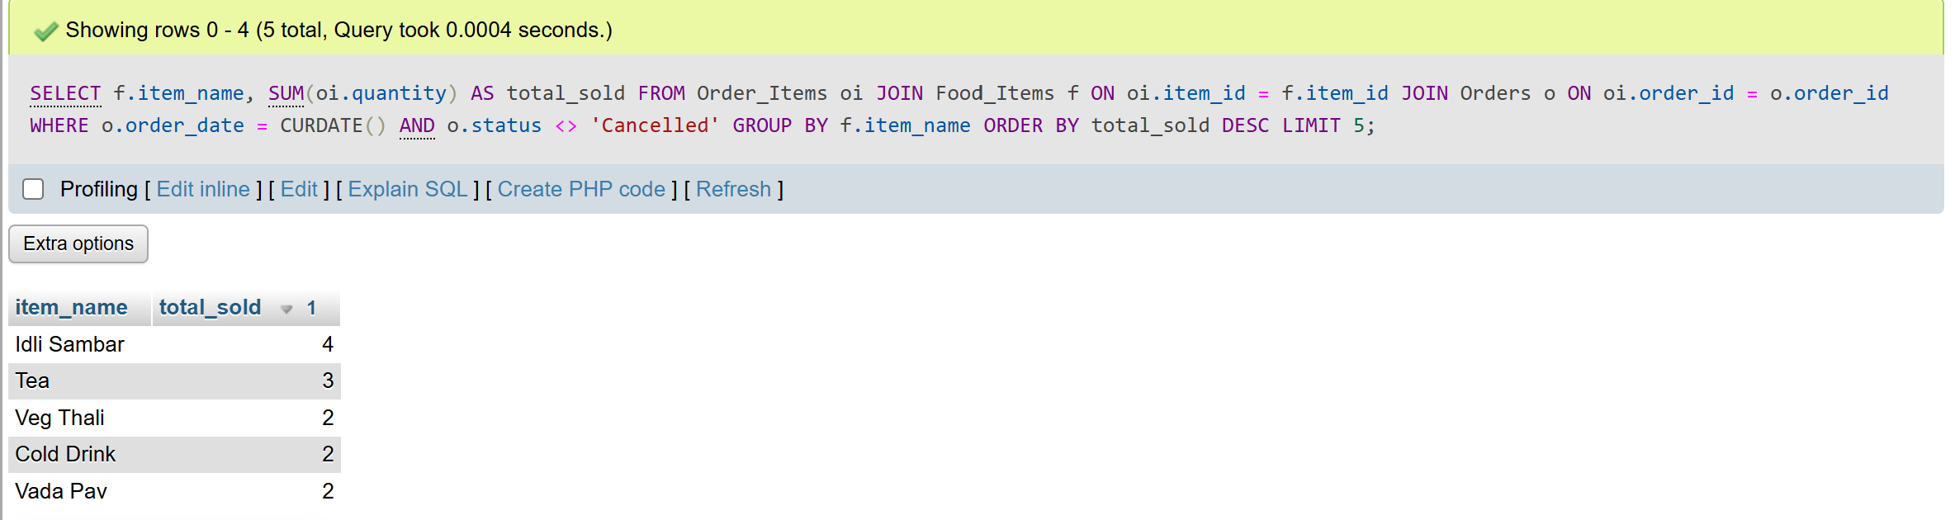
Figure 16: Output of Q3 (best-selling items today)
Q4 finds the students whose total spending is above Rs. 100.
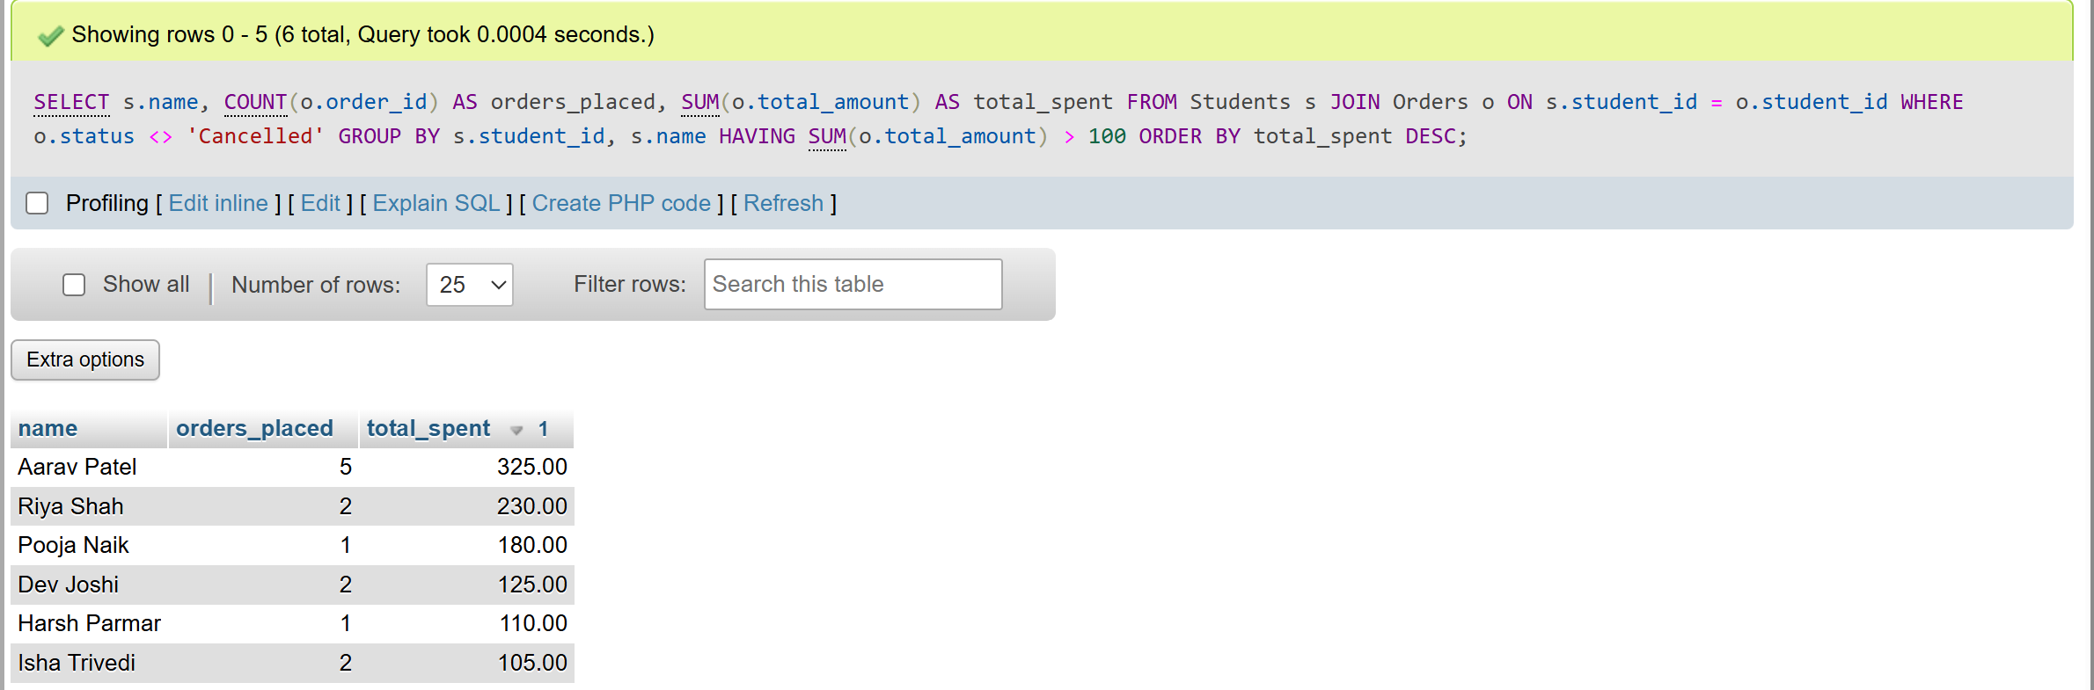
Figure 17: Output of Q4 (students with total spending above 100)

4.4 Test Summary
Test case | Expected result | Evidence | Result
Quantity above stock in the form | Value refused | Figure 6 | Pass
Place an order (Sandwich x2) | Token issued, total Rs. 80.00 | Figure 7 | Pass
Status flow and cancel | Pending, Preparing, Ready, Collected, Cancelled | Figure 8 | Pass
New day | Token restarts at 1 | Figure 10 | Pass
Report with cancelled orders | Cancelled orders excluded from revenue | Figure 9 | Pass
End-of-day summary | Daily_Sales row for each date | Figure 11 | Pass

5. CONCLUSION & REFERENCES

5.1 Summary
The project delivers a working canteen ordering website on a normalised MySQL database. Orders are stored with a daily token, stock and totals stay correct through a trigger, and the owner gets a daily sales report from one procedure call. The design demonstrates an ER model with M:N resolution, normalisation up to 3NF, constraints, JOIN and GROUP BY queries, views, a function, a procedure and a trigger, together with HTML and CSS pages written in PHP.

5.2 Limitations & Future Improvements
Limitations
- There is no login, so any person can place an order for any student.
- Payment is recorded outside the system.
- The pages are designed for a desktop browser and are not tuned for small phone screens.
- Category is stored as text in Food_Items instead of a separate table, which was a deliberate simplification.
- The next token is read as the highest token of the day plus one, so two orders placed at the same instant could collide; the UNIQUE constraint on (order_date, token_no) rejects the second one and the order would have to be retried.
- Stock is returned on cancellation by the PHP page, not by the database, so a cancellation made directly in SQL does not restore stock.
Future improvements
- Student and staff login with roles.
- A prepaid wallet and online payment.
- Peak-hour analytics and demand forecasting to reduce waste.
- A student feedback and rating table.
- A separate Food_Categories table and a Staff table.

5.3 References / Sources
- Elmasri, R., & Navathe, S. B., “Fundamentals of Database Systems”, 7th Edition, Pearson.
- Silberschatz, A., Korth, H. F., & Sudarshan, S., “Database System Concepts”, 7th Edition, McGraw-Hill.
- MySQL Reference Manual, Oracle Corporation, https://dev.mysql.com/doc/
- PHP Manual, https://www.php.net/manual/en/
- XAMPP and phpMyAdmin documentation, https://www.apachefriends.org and https://www.phpmyadmin.net
- Database Management Systems course material, A.D. Patel Institute of Technology.

